Game 5: Proton’s got moves

**Why?**

Nuclear magnetic resonance is the key physical phenomenon and the basis for MRI. The nuclei of hydrogen atoms everywhere in our bodies always spin around its axis, generating tiny magnetic moments. To interact with them, we must talk in their magnetic language by applying 3 different types of magnetic fields at appropriate frequencies so they dance in harmony and emit a signal we can listen to. If you understand the cool moves of protons, you can be a spin choreographer and make them reveal what’s inside you.

**Materials**

* Gyroscope
* Copper coil
* Small bar magnet
* Multimeter

**Background**

1. Key terms
2. **Spin**: Protons, neutrons, and electrons all have **intrinsic** angular momentum, also called spin. These subatomic particles are always rotating around their own center axes by nature. In the image, the Angular Momentum vector (L) of a cylinder points along the right-handed axis of its rotation.

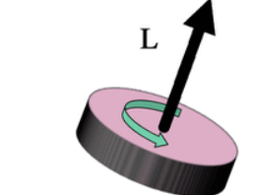



1. **Magnetic moment** is a vector that measures how much of a magnet a thing is and the direction of this magneticness. A loop of wire carrying a current has a magnetic moment, and so does a fridge magnet. Protons are magnets too, and each of them has a fixed magnetic moment μ.
2. **Net Magnetization (M)**: Because the protons and their magnetic moments are small, it is preferable to think about the sum of their behavior rather than trying to model each individual proton. Net Magnetization (M) is the average vector of all the proton magnetic moments within a volume in space.

When there is no outside magnetic field, the spins are all pointing at random directions and M is zero. When you turn on such a field and keep it on, however, net magnetization develops and ends up larger for higher magnetic field strengths because of energy level effects.

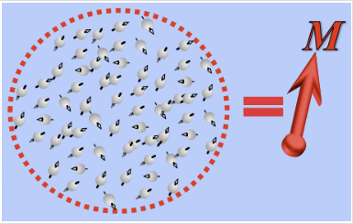



1. **Main magnetic field** is a strong magnetic field (clinically, about 30000 to 70000 times Earth’s field) essential to MR. It is made highly uniform and points along the z axis. When you go into the MR scanner, you are under its influence and a net magnetization vector develops in you.
2. **Precession** is the motion of the protons as they spin around the axis of the main magnetic field in a cone like manner. This happens partly because the protons have angular momentum, and partly because the main magnetic field is pulling on the proton’s magnetic moment.

You can see similar effects with spinning tops when they go off axis and rotating wheels suspended on strings at an angle. Precession gets faster when you use stronger magnetic fields.

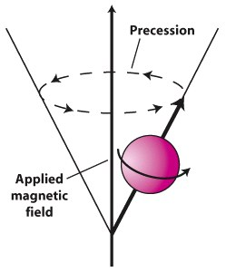



1. **Rotating frame of reference:** Since the magnetic moment is rotating so fast, its movement can quickly become very complicated when we start turning on additional magnetic fields. The way to simplify this motion is to pretend that we are also going around the precession axis at exactly the same speed, in a mad merry-go-round kind of way. Once we are on this bandwagon, the spin’s magnetic moment seems to stay still. It is just like how two people standing on two trains side by side moving at the same speed seem stationary to each other.
2. **Radiofrequency (RF) pulses** are how we talk to spins using a second, more short-lived, magnetic field. The RF field is perpendicular to the main field and has to rotate as fast as the spin’s precession to catch up with it. Once it catches up, it flips the spins as if turning a wrench, knocking them out of the comfortable z equilibrium and towards the xy plane. Then, after we’ve rotated the desired amount, the pulse is turned off.

The axis of rotation is along the RF field vector itself and the angle is proportional to both the strength and the duration of the pulse. The figure below shows how M is turned by 90 degrees in (b) and then spreads out because individual spins have slightly different frequencies in real life.

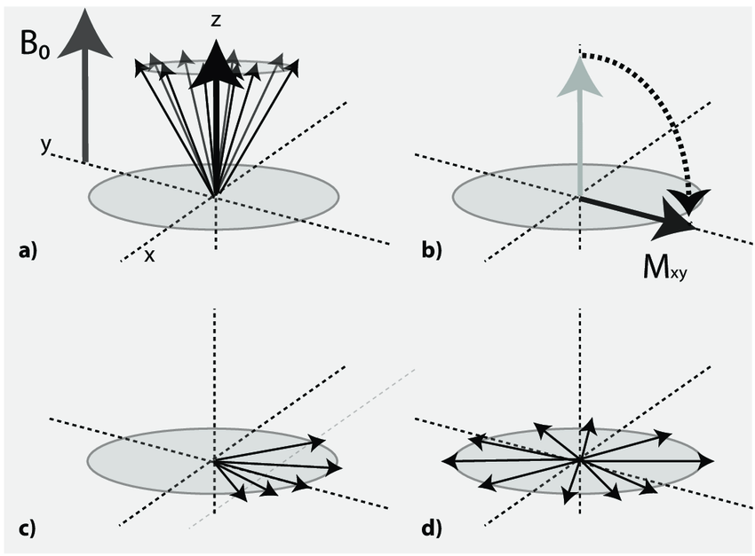



1. **Nutation**: It is just another word for RF rotation of the net magnetization vector to distinguish it from precession.

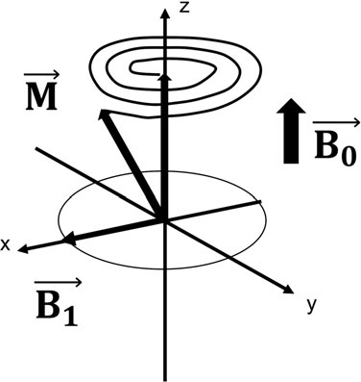



1. **Electromotive force**: This is the electrical potential difference, or voltage, created, when the magnetic flux across a looped wire, also called a coil, changes. This happens only when a coil is placed correctly, in a way that magnetic fields generated by the net magnetization M pass through it. When M is in precession, a sinusoidal voltage can be measured across the coil.

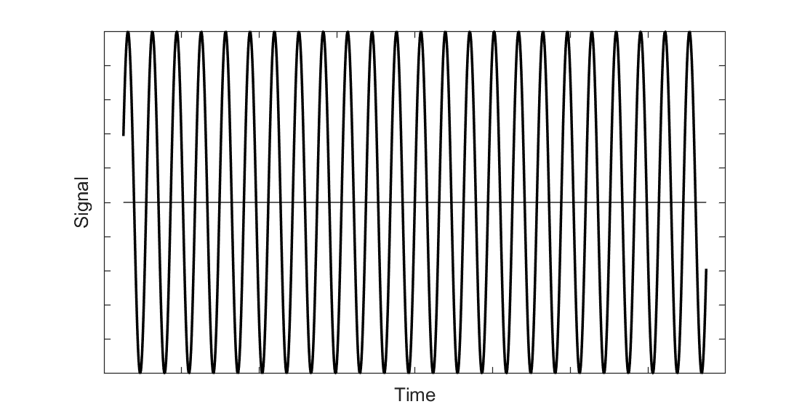

1. **Free induction decay**: This is the more realistic emf signal that occurs right after the 90 degree RF pulse. Due to interactions between spins causing them to have slightly different frequencies over time, the signal goes down to zero exponentially at predictable rates described by the T2 tissue parameter.

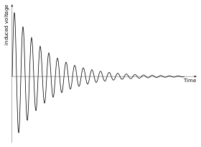



1. Lab procedures:
   1. “The Equilibrating Move” - Equilibrium Magnetization
      1. Turn on the main field by clicking on . Once it is turned on, adjust the main field value and note down your observations.

As the main field is turned up, ____________________________.

* 1. “The Circulating Move” - Precession

i. Under guidance of the mentor, take the gyroscope (or bicycle wheel, or spinning top) and tip it at an angle. Release. Then repeat the step after making it rotate around its own axis first. What are the forces acting on the gyroscope and how does its motion change when it’s being spinned versus when it’s not?

ii. Make sure the rotating frame is turned off. Then set the initial magnetization to have a nonzero x or y component (for example: theta = 45, phi = 45, size = 1).

iii. Hit the “RUN” button. What do you observe? How does each component of the magnetization vector (Mx, My, Mz) change in time?

* Mx :
* My :
* Mz :

iv. Change the main field strength and hit “RUN” again. What is the difference?

v. Turn on the rotating frame. We are now essentially traveling on a merry-go-round that’s matched to the spin’s frequency. What do you see now?

vi. Imagine for a moment and answer: what do we see if our merry-go-round is going faster than the spin? What if we are going slower?

* 1. “The Tipping Move” - RF pulses

I. Push “RESET” to turn off everything. Then turn on B0 and wait until the equilibrium M is fully developed.

ii. Push the button “Show RF” to display the direction of the RF magnetic field.

iii. Adjust the flip angle and pulse direction

iv. Make sure both the main field and the rotating frame are turned on . Then push “Tip”. The spin should move.

v. Repeat i-iv with five different values and note your observations in the table below:

| Flip Angle | Pulse Direction | Observations |
| --- | --- | --- |
|  |  |  |
|  |  |  |
|  |  |  |
|  |  |  |

Vi. On the “set initial magnetization” panel, you can choose to have M0 start with any direction. Try to make the spin vector rotate to the designated final positions for the following settings with the RF pulse and record the steps. You may use up to 3 RF pulses (FA: flip angle; DIR: pulse direction). The fewer pulses you use, the more kudos you get!

| Initial M (always use |M/M0| = 1) | Final (Mx,My,Mz) | FA 1 | DIR 1 | FA 2 | DIR 2 | FA 3 | DIR 3 |
| --- | --- | --- | --- | --- | --- | --- | --- |
| theta = 90, phi = 90 | (0,0,1) |  |  |  |  |  |  |
| theta = 90, phi = 0 | (-1,0,0) |  |  |  |  |  |  |
| theta = 90, phi = 0 | (0,1,0) |  |  |  |  |  |  |
| theta = 45, phi = 90 | (1,0,0) |  |  |  |  |  |  |
| theta = 0, phi = 0 | (0,1/2,-sqrt(3)/2) |  |  |  |  |  |  |

* 1. “The Electrifying Move” - Signal induction

I. Connect the wire loop to the spectrometer and try moving the bar magnet in different ways: rotating next to the coil, moving towards and away from the coil, moving parallel to the coil, and so on. How can you generate the most signal?

ii. Push the “RESET” button to turn off everything. Then turn on B0 and wait until the equilibrium M is fully developed.

iii. Push the bull’s eye icon to turn on the receive coil.

iv. Is there a signal now? Why?

v. Set the magnetization to x or y. Then hit “RUN”. Is there a signal now? Why?

vi. Change field strengths and hit “RUN” again each time. Record your observations below:

| Field strength (gauss) | Effects on spin | Effects on signal plot |
| --- | --- | --- |
|  |  |  |
|  |  |  |
|  |  |  |
|  |  |  |
|  |  |  |

vi. Set the initial magnetization to have different values of theta and/or phi and hit “RUN”. Record your observations.

| Theta | Phi | Observations |
| --- | --- | --- |
|  |  |  |
|  |  |  |
|  |  |  |
|  |  |  |

What matters in determining signal amplitude? What does not?

1. Questions
2. What is the difference between a 90 degree RF pulse and a 180 degree RF pulse?
3. The 90 degree pulse is shorter than the 180 degree pulse
4. The 90 degree pulse is at a right angle to the spin magnetic moment while the 180 degree pulse is antiparallel to it
5. The 90 degree pulse rotate half the number of spins compared to the 180 degree pulse
6. The 90 degree pulse tips the equilibrium M to the x-y plane while the 180 degree pulse does not

(2) Why do we need to apply an RF pulse?

1. The spins absorbs the RF energy and converts it into heat, which can then be detected by the coil
2. The RF pulse allows spins to develop a magnetic moment which is necessary for signal generation
3. The spin magnetic moments start out along z but cannot be detected unless tipped so they lie in the x-y plane
4. The spins precess around the transmitted RF field to generate emf in the receiving coil

(3) What happens to the emf signal when the main magnetic field is turned up?

1. The signal oscillates faster
2. The signal oscillates more slowly
3. The signal decays faster
4. The signal decays more slowly

(4) Among the four options, which one maximizes the voltage range of the received signal at a constant main field? The initial magnetization is at equilibrium and points along z.

1. Use a 5-degree pulse with a phase of 180 degrees
2. Use a 85-degree pulse with a phase of 45 degrees
3. Use a 179-degree pulse with a phase of 0 degrees
4. Use a 225-degree pulse with a phase 0f 76 degrees